
SCSE 2123: Software Requirements Engineering
Semester 01, 2025/2026

User Requirements Definition

<Project Title>

<Version ID>

<Printing Date>

Prepared by: < Team name>
<Team Motto>

DOCUMENT CONTROL
General Information
Document Name | : | <Document ID> – User Requirements Definition
Audience | : | << Targeted audiences >>
Prepared by | : | <<Name of your team >>
Prepared Date | : | << Date >>
Revision Date | : | << Date >>
Printed Date | : | << Date >>
Reference Number | : | << Reference number >>
Version | : | << Version >>
Document Level | : | Confidential | Open

- Current Version Document
 | Name | Designation | Signature | Date
Prepared by: | <<Member name>> | <<Role>> | <<Compulsory>>
Verified by: | Dr. Noraini Ibrahim | Head of Project | TBD | TBD

Table of Contents

No. | Item | Page # | Prepared by: | Moderated by:
1.0 | INTRODUCTION
1.1 | Purpose
1.2 | Scope
1.3 | Definitions, Acronyms and Abbreviations
1.4 | References
1.5 | Overview
2.0 | PROPOSED SYSTEM VISIONS
3.0 | AS-IS (CURRENT) PROCESS ANALYSIS
3.1 | <<As-Is Process #1>>
3.1.1 | Swimlane Model
3.1.2 | Related Documents
3.1.3 | Issues in current process
3.1.4 | Improvement Suggestion
3.n | <<As-Is Process #n>>
3.n.1 | Swimlane Model
3.n.2 | Related Documents
3.n.3 | Issues in current process
3.n.4 | Improvement Suggestion
4.0 | PROPOSED (TO-BE) PROCESS
4.1 | <<To-Be Process #1>>
4.1.1 | Swimlane Model
4.1.2 | Related Business Rules
4.n | <<To-Be Process #n>>
4.n.1 | Swimlane Model
4.n.2 | Related Business Rules
5.0 | APPENDICES

INTRODUCTION
The following section and subsections of the User Requirements Definition (URD) document should provide the details of the entire URD. Remove the notes in read texts including these notes.

  - Purpose
This subsection should:
- Delineate the purpose of the URD;
- Specify the intended audience for the URD

This URD describes…

  - Scope
This subsection should:
- Identify the software product(s) to be produced by name (e.g., Host DBMS, Report Generator, etc.);
- Explain what the software product(s) will, and, if necessary, will not do;
- Describe the application of the software being specified, including relevant benefits, objectives, and goals;
- Be consistent with similar statements in higher-level specifications (e.g., the system requirements specification), if they exist.

The software product is…

  - Definitions, Acronyms and Abbreviation
This subsection should provide the definitions of all terms, acronyms, and abbreviations required to properly interpret the URD. This information may be provided by reference to one or more appendixes in the URD or by reference to other documents.

Definitions of all terms, acronyms and abbreviation used are to be defined here.

  - References
This subsection should:
- Provide a complete list of all documents referenced elsewhere in the URD;
- Identify each document by title, report number (if applicable), date, and publishing organization;
- Specify the sources from which the references can be obtained.

Specify complete list of references using a standardized APA reference format.
  - Overview
This subsection should:
- Describe what the rest of the URD contains;
- Explain how the URDs organized.

Give an overview of the content of this URD document.

PROPOSED SYSTEM VISIONS

2. Goal Model
This subsection should:
- Describe the system visions visualization using Goal diagram;
- Explain the goals decomposition (AND/OR);

Give brief description of the system visions to be proposed as high-level of objectives. Describe the root/main goal and sub-goals decomposition as presented in the diagram.
[Include the Goals hierarchy here]
[Place your figure here]
Figure 2.1: Goal Model of <Proposed System>

AS-IS (CURRENT) PROCESS ANALYSIS
This section of the URD should describe the identified flow of identified existing process practiced by the organization.

  - << As-Is Process Name 1>>
Give brief description of the process i.e., involved roles/stakeholders

    - Swimlane Model
[Include the process Swimlane here]
[Place your figure here]
Figure 3.1: Swimlane Diagram of <Name of the Process>

    - Related Documents
This should specify all related documents, which need to be considered in the current process. This could be the guideline document, the SOP documents.
List the documents here

    - Issues in current process
This should specify all identified problems or issues currently facing by the involved parties in the current process.
List and specify all related issues here….

    - Improvement Suggestions
This should specify suggestion to improve the current process based on identified issues in 2.1.3.

List and specify all your suggestions here..

  - << As-Is Process Name n>>
:
:
:
:

PROPOSED (TO-BE) PROCESS
This section of the URD should describe the proposed flow of the proposed automated system for each of the identified as-is process
  - << To-Be Process#1 Name >>
Give brief description of the process

    - Swimlane Model
[Include the process Swimlane here]
[Place your figure here]
Figure 4.1: Swimlane Diagram of <Name of the Process>

    - Business Rules
This should specify all related business rules to this proposed process.
“Business rules include corporate policies, government regulations, industry standards, and computational algorithms (Refer to Chapter 9 - K. Wiegers and J. Beatty, Software Requirements, 3rd Edition. Washington: Microsoft Press, 2014) & The Business Rules Group (https://www.businessrulesgroup.org/first_paper/BRG-whatisBR_3ed.pdf )
List the related business rules here…

  - << To-Be Process#n Name>>
:
:
:
:

APPENDICES
[Include any related documents, screenshots of legacy system, interview and survey questionnaires – that were observed and compiled to understand the system and it’s relevant context – boundary, scope, objects, interfaces]
- Appendix A: Originality/Similarity Report
  - Attach the originality/ similarity report (.pdf file) from Turnitin checking.
  - UTM teaching and learning best practice for plagiarism policy is similarity index must less than (=<) 20%
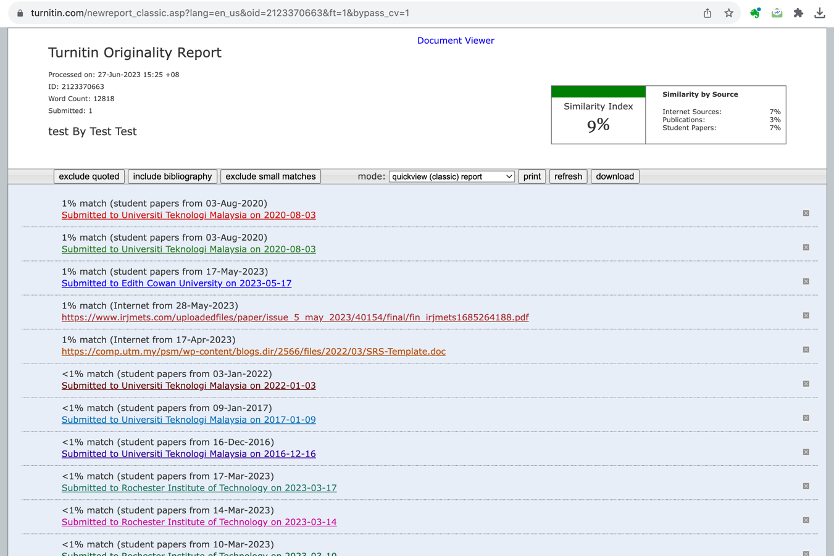



- Appendix B: List of Prompts Used
  - Include verifiable evidence of the use of Generative AI tools such as ChatGPT, QuillBot, etc., in the creation of your assignment.
  - This evidence may include screenshots and URL links
  - Failure to provide this evidence when actually you are using generative AI in your work will result in ethical violations and may lead to plagiarism penalties, ultimately resulting in a grade deduction to zero marks.

* Generative Artificial Intelligence refers to a type of artificial intelligence technology that can produce various types of content, including text, images, audio, and synthetic data
Example: Screenshot
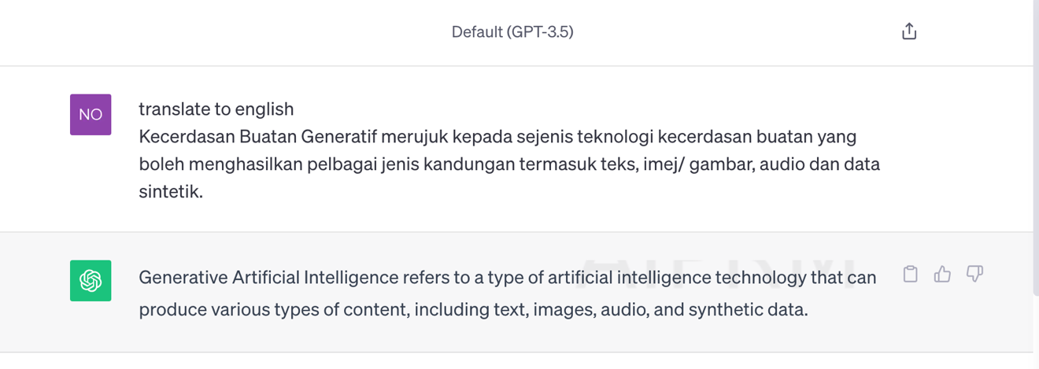
Figure: Screenshot Generative AI translation from BM to English
Example: URL
https://chat.openai.com/share/0ff33fdd-9b7f-407c-9b74-b744ec698a7e>

